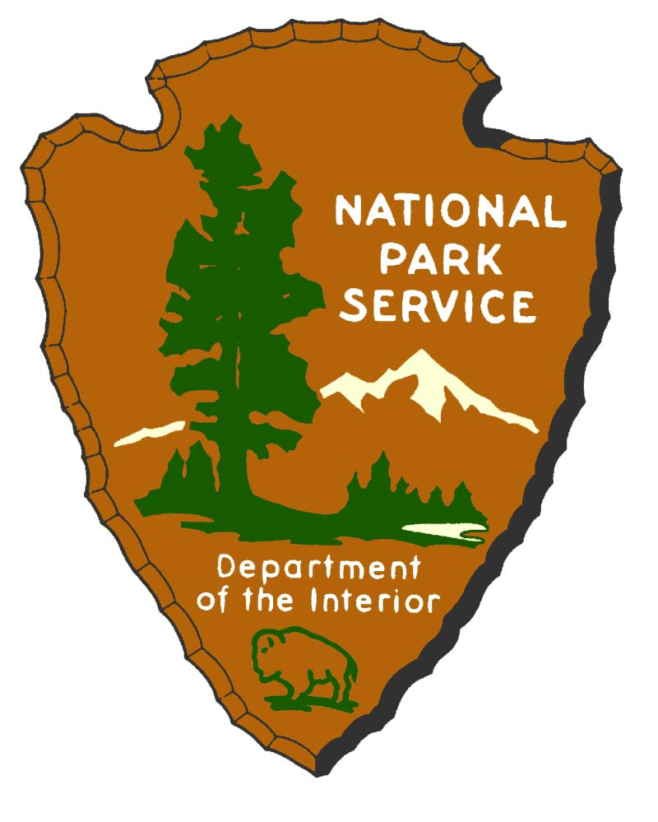
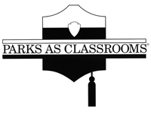

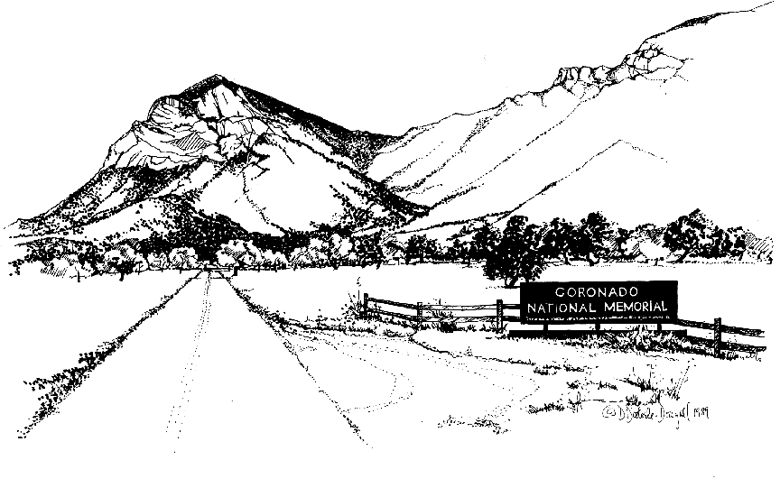
Coronado National Memorial

History Education Program

Teacher's Guide

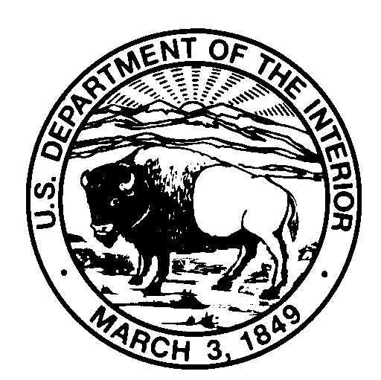  IN REPLY REFER TO : | United States Department of the Interior  NATIONAL PARK SERVICE  CORONADO NATIONAL MEMORIAL  4101 E. Montezuma Canyon Road  Hereford, Arizona 85615 | 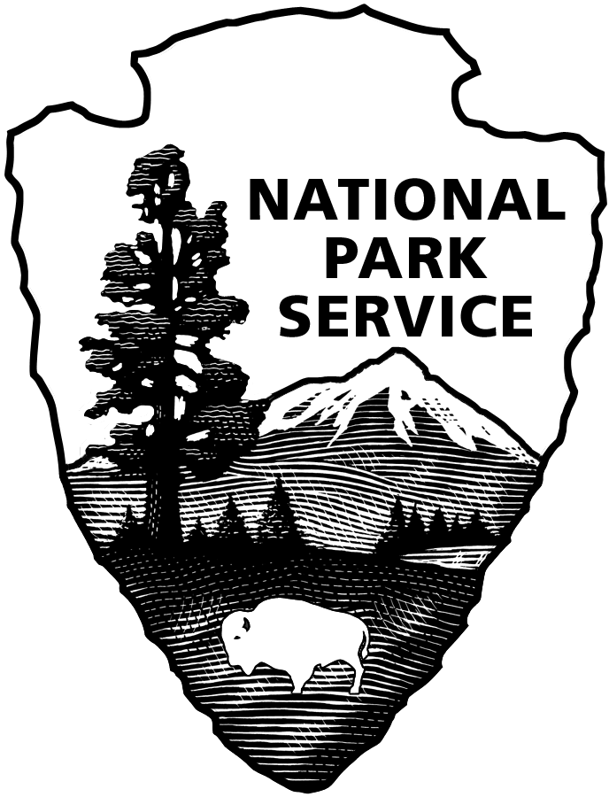

Dear Instructor:

Thank you for arranging a natural and cultural history field trip to Coronado National Memorial. We are delighted you are taking the opportunity to use Coronado National Memorial to enhance the classroom learning experience. This guide is designed to provide learning tools for use in the classroom to help prepare you and your students for your visit to our park. The purpose is to:

1. Give you ideas for developing a unit on Coronado's Expedition.

2. Lay a foundation of knowledge that the program leaders can build upon.

3. Build anticipation for the program at the Memorial.

4. Stimulate interest in local history among the students.

Your students will learn the most from this education program if they spend time preparing for it. As a teacher, you are the essential link to a successful program. This packet of materials contains a Teacher's Guide with useful information about the park, the logistics of your visit and an Activities Guide with classroom exercises. Please use this packet to prepare your students for their visit.

We look forward to having you and your students participate in our program and hope that the information provided will be beneficial. This program was funded with grants from the National Park Foundation and the Western National Parks Association.

THEME, GOALS AND OBJECTIVES

THEME: The Coronado Expedition of 1540-1542 from Mexico City to Kansas had a profound effect on the American southwest, irrevocably changing the lives of the native peoples and demonstrating the need for understanding and communication when interacting with diverse cultures.

GOALS:

. Give students an overview of the expedition, its goals and the route taken.

. Develop students’ appreciation for the cultural diversity of the area by emphasizing both the Spanish and Native American cultures and lifestyles during the period of first contact.

. Familiarize students with the clothing, weapons and tools of both the Spanish conquistadors and the Pueblo Indians.

. Acquaint students with native flora and fauna used by Indians for food, textiles and utility items.

OBJECTIVES

. After doing the pre-visit activities, students will be able to draw Coronado's route on a map and name the three goals of the Expedition.

. By seeing, touching and dressing in replica items, students will be able to recognize, identify and compare armor, weapons, tools and clothing used by both Spaniards and Indians, and the materials from which the items were made.

. By viewing the scale model of a Pueblo, students will be able to compare and contrast Spanish and Indian battle strategies and describe how these affected their decisions and the outcome of their confrontation.

. By reenacting the encounter between Spaniards and Zunis and comparing it to modern day events, students will be able to explain how conflicts in their everyday lives may be avoided by understanding the language and cultural differences of their peers.

. By viewing trees and shrubs and participating in hands-on demonstrations, students will be able to identify some of the native plants found along the Expedition route and describe how they were utilized, processed, cooked and eaten.

PROGRAM LOGISTICS

Preparing for your visit to Coronado National Memorial
The students will become familiar with the Coronado expedition by doing many of the activities found in the Activity Guide. An evaluation quiz has been provided for your convenience.

Directions to the Memorial
From Sierra Vista, travel south on AZ 92 to Coronado Memorial Road. Turn south (right) and proceed 5 miles to the Visitor Center. From Bisbee and Palominas, take AZ 92 west to Coronado Memorial Road turn south (left) and proceed 5 miles to the Visitor Center. Buses will be met by a park ranger at the picnic area. At the end of the picnic area the bus will turn around and the students will disembark.

At the Memorial
Children and teachers should disembark in the picnic area cul-de-sac. The students will divide into four previously arranged groups. Two groups (one class) will go to the Food and Fibers stations; the other two groups will go to the Spaniard and Zuni stations. At the midpoint of the program there will be a short restroom break, then the groups will switch places so all students may participate in all activities. Restrooms are located in the picnic area and at the Visitor Center. Students should visit the restrooms under adult supervision during the break provided halfway through the program.
Lunches and other belongings should be left on the bus. If the bus will not be staying at the Memorial, lunches must be placed in large cardboard boxes that can be shut to keep critters from eating the food. Students will have ample time after the program to eat. A trip up to the Visitor Center may also be planned and students may wish to make small purchases.

Program Description
During the three-hour program at the Memorial, students rotate through three activity stations.
- Reenactment of the first encounter between the Spaniards and Zuni. (2 groups)
- Information on native plants used for fibers. (1 group)
- Instruction on native plants and animals used for food and seasoning. Tasting blue corn chips, salsa, and prickly pear cactus juice. (1 group)

Inclement Weather
Due to the number of students and extremely limited space in the Visitor Center, we will not be able to offer alternative activities during inclement weather. We hold the activities in the picnic area under covered ramadas, however, if you feel that you do not want to subject your students to bad weather, call the Visitor Center between 8:00 and 8:30 the morning of your scheduled trip to cancel. The phone number is 366-5515. Even in good weather, it is important that students bring along jackets. The picnic area is located at an elevation of 5200 feet and some mornings can be quite windy and chilly.

Field Trip Preparation

Your visit to Coronado National Memorial will be a success if you prepare your students through classroom lessons and activities and follow these guidelines:

- Groups- Each class should be divided into two groups. Name each group in order to be able to divide them easily. (Example: group 1 and group 2; purple group and red group) Please have this done before you arrive and make sure each student knows his/her group to avoid confusion at the park. Teachers should divide the groups in a manner that will reduce disruptive behavior.

- Supervision- At least one adult should be with each small group at all times. At least one parent for every ten children in addition to the teacher is suggested. Please make sure parents are aware they are responsible for keeping discipline in their groups. Remember, this program is being conducted by volunteers and they should not be expected to perform disciplinary actions. Children often are more attentive when they are NOT in the same group with their parents.

- Behavior- Students are encouraged to ask questions, but will be expected to pay attention and listen quietly to instructors and other students. Animals are more likely to be seen when the students are quiet.

- Name Tags- Have visible name tags on each student with large bold print. First name only is fine. Make sure they are handed out and put on before arriving at the park.

- Clothing- Students should wear comfortable clothing. Bring along a jacket or sweater as the activities will be outdoors. Closed-toed shoes are recommended.

- Photographs- Teachers are encouraged to bring a camera to take pictures. You can create a display back in the classroom. Students should not bring along cameras or binoculars; these items create more distracting than helpful.

- Lunch- Students and teachers should bring lunches which will be left on the bus. If your bus can not stay, have lunches in large cardboard boxes that can be closed as birds will eat any exposed food. Lunches may be eaten in the picnic area after the program is completed. No food, gum, candy, or beverages, other than water, are allowed during the program.

- Spending Money- A trip to the Visitor Center after lunch may be planned. Books, postcards, posters, patches, and pins are sold in the Visitor Center. Each group should decide ahead of time whether or not spending money will be brought.

Park Rules and Safety

To help preserve the natural beauty and the historic and scientific values of the park and to protect students during your visit, the following regulations and safety messages have been established. The following should be discussed with your students and adult leaders before arriving at the memorial.

- Always follow directions of park staff and/or volunteers.

- Stay on paths and trails behind your leader and remain in your group.

- Walk, do not run.

- Wildlife must not be fed or disturbed.

- Avoid handling plants. Many have spines and thorns and can be painful.

- Collecting objects is prohibited. Leave everything for others to enjoy.

- Venomous animals live in the desert. These include rattlesnakes, scorpions and gila monsters. The best way to avoid injury is to avoid placing your hands and feet in crevices. Never put your hands and feet where your eyes have not been.

- Listen to your group leader for additional safety messages.

In Case of Emergency

Please leave the Visitor Center telephone number with your school in case of an emergency. You and your class may be contacted at 520-366-5515. The address is: Coronado National Memorial, 4101 E. Montezuma Canyon Road, Hereford, AZ 85615.

Fourth Grade Education Program Evaluation

Circle a letter for the correct answer.

1. Francisco Vasquez de Coronado was
a. A Zuni Indian
b. A Spanish Priest
c. A Spanish King
d. A Spanish Explorer

2. The Spaniards came to this area
a. To find diamonds
- To steal sheep
- To find gold
d. To buy horses

3. What food did the Zunis eat?
a. Apples
b. Hamburgers
c. Corn
d. Lettuce

4. What plant did the Zunis use for fiber?
a. Corn
b. Yucca
c. Wool
d. Oak Trees

5. Why didn’t the Zunis want the Spanish to come into their pueblo?
- They didn’t want the Spanish to take their guns.
- They were having a meeting with English explorers.
- They didn’t want the Spanish to take their horses.
- They were having a sacred corn ceremony.



